The Challenge
Background: The European Union Framework Programme 7 (FP7) Thorax Model (THOMO) project
Gendered Innovation 1: Modeling Women's and Men's Thoraxes
Method: Rethinking Research Priorities and Outcomes
Gendered Innovation 2: Consistent Biomechanical Testing across Female and Male Thoraxes
Method: Rethinking Standards and Reference Models
Potential Value Added to Future Research through the Application of Gendered Innovations Methods
Potential Value Added 1: Studying the Effects of Age and Menopausal Status on Thoracic Bone Architecture
Method: Analyzing Factors Intersecting with Sex and Gender
Potential Value Added 2: Including Geographically-Diverse Populations
Method: Analyzing Factors Intersecting with Sex and Gender
Potential Value Added 3: Modeling Breast Tissue
Method: Formulating Research Questions

The Challenge
Road traffic collisions are a major cause of mortality and morbidity in the European Union and the U.S.; in 2009, collisions resulted in an estimated 34,500 deaths in the EU-27 and 30,862 deaths in the U.S. (Eurostat, 2011; NHTSA, 2012). Deaths are also concentrated among men. In both the EU and U.S., men are 2.6 times as likely as women to die in road collisions (DG Energy and Transport, 2009; Kposowa et al., 2009).
Multiple research projects have been undertaken with the goal of developing a finite-element model of the human body to enhance safety engineering. Consistently, models have been initially based on 50th percentile male anthropometry, with some models later expanded to include larger and smaller bodies (Yang et al., 2006). Following this pattern, the Human Model for Safety (HUMOS-1), funded under the EC Fourth Framework Programme (FP4) from 1997 to 2000, was based on the study of a single male cadaver, representing "a 50th percentile seated man" (Pajon et al., 2002).
HUMOS-2, funded under the EC Fifth Framework Programme (FP5) from 2002 to 2006, expanded data collection to include humans from the 5th, 50th, and 95th percentiles,—i.e., lighter people (mostly women) and heavier people (mostly men) (Toma et al., 2010; Acart et al., 2009a; Dupont-Kerlan et al., 2006). Biofidelic models are, however, still developed first for the 50th percentile man, from the outset excluding people who are significantly smaller or larger. One such example is the Global Human Body Models Consortium (GHMBC) model (GHMBC, 2012).

Background
The European Union Framework Programme 7 (FP7) Thorax Model (THOMO) project aims to develop a numerical, "finite element model of the human thorax and upper extremities" (THOMO, 2012). Data-gathering procedures by THOMO and associated research teams can be sorted into two basic categories:
- A. Measurement of the thoracic skeleton (imaging of ribs, sternum, vertebrae, and cartilage) with computed tomography (CT), laser scans, and microtomography (μCT) (Mayeur et al., 2010).
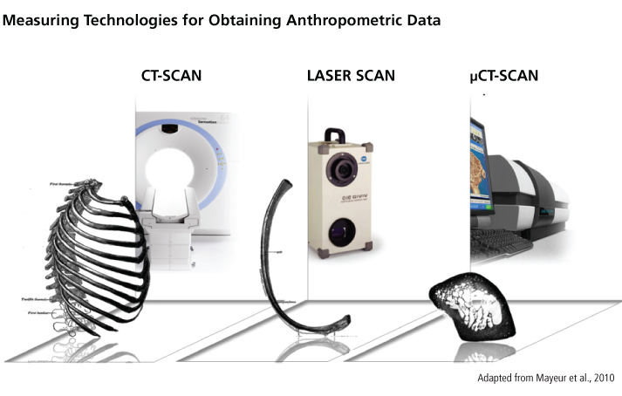
- B. Biomechanical stress tests on cadaver ribcages. Dynamic test endpoints include deformation under strain and actual fractures.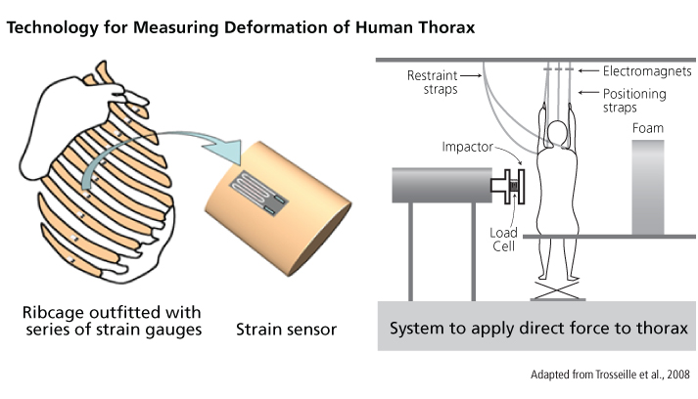
Biomechanical tests are designed to simulate forces exerted on the thorax from both front- and side-impact automotive crashes. Tests cover a variety of scenarios, including drivers/passengers who are wearing 3-point seatbelts, wearing 4-point harnesses, or unbelted, in crashes with or without airbag deployment.
THOMO project measurements and biomechanical tests are performed on cadavers from France corresponding to the following percentiles of overall human body weight:
- 50th (11 male cadavers and 1 female cadaver)
- 5th (6 female cadavers)
THOMO uses scaling to model other size percentiles (THOMO, 2012).
THOMO is one of four biomechanical modeling projects under the EU's Coordination of Vehicle and Road Safety Initiatives (COVER) consortium. All COVER projects are funded under FP7 and each has a distinct focus (Lemmen et al., 2009) - see diagram:
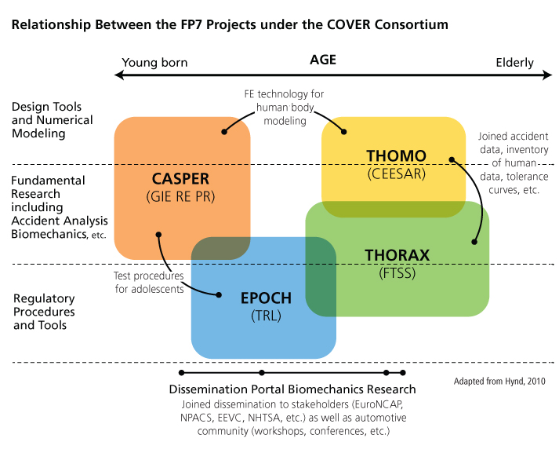
The THOMO project is one of several Centers of Expertise for the privately funded Global Human Body Models Consortium (GHMBC), which consists of nine automobile manufacturers from EU countries, the U.S., South Korea, and Japan, as well as the U.S. National Highway Traffic Safety Administration (NHTSA) (GHBMC, 2012).
Automotive manufacturers continue to develop finite-element models for safety engineering purposes (Leonardi, 2009). One example is the Total Human Model for Safety (THUMS), a proprietary project of the Toyota Motor Corporation (Maeno et al., 2001). The initial version of THUMS was based on anthropometry of a 50th percentile U.S. man (Chawala et al., 2005; Oshita et al., 2002). Currently, engineers are expanding the model to include 5th percentile American women, 95th percentile American men, and pregnant women (Iwamoto et al., 2007).

Gendered Innovation 1: Modeling Women's and Men's Thoraxes
The THOMO project models both women's and men's thoraxes by gathering data from bodies ranging from the 5th to 50th weight percentiles (THOMO, 2012).

Method: Rethinking Research Priorities and Outcomes
Studies of crash outcomes show that women drivers are approximately 47% more likely than men drivers to sustain severe injuries in automotive crashes when researchers control for factors such as height, weight, seatbelt usage, and crash intensity; that is to say, a seatbelt-wearing woman driver involved in a crash is more likely to be injured than a seatbelt-wearing man driver of identical height, weight, and age involved in an identical crash (Dipan et al., 2011; Evans, 1999). Several sex and gender factors may influence observed differences in crash outcomes:
- 1. Injury threshold: Women have a lower average injury threshold than men for some mechanisms of injury, such as whiplash, but young men have a lower velocity injury threshold than young women (Talmor et al., 2010; Stemper et al., 2004).
- 2. Design: Women may have excess risk because "effectiveness of occupant safety devices is biased toward the male occupants" (Dipan et al., 2011).
- 3. Type of vehicle driven: In the U.S., where data are available, women tend to drive cars with higher safety ratings than do men (Ryb et al., 2010).
View General Method

Gendered Innovation 2: Consistent Biomechanical Testing of Female and Male Thoraxes
THOMO researchers have performed tests on small, mostly female thoraxes while maintaining consistency with instrumentation and data-reporting protocols previously applied to mostly male thoraxes. This method allows cross-sex comparison of strain profiles and the development of a more comprehensive reference model.

Method: Rethinking Standards and Reference Models
Physical strain tests are critical to developing biofidelic models.
Historically, a 50th percentile male cadaver thorax was used as a reference in frontal impact tests in EU-supported crash testing (Behr et al., 2003). This reference model did not account for lighter people's anatomy, and researchers who developed it recommended further work to "develop injury risk functions for female and elderly" drivers and passengers (Carroll, 2010). 50th percentile models also leave out larger people, and researchers assessing the "injury reduction potential" of automotive safety research assert that "the use of a larger than average size dummy could lead to the greatest benefit" (Carrol et al., 2010). THOMO researchers have worked to expand reference models of the thorax beyond the 50th percentile to include 5th percentile human body sizes. In light of this, THOMO researchers have prioritized creating a biofidelic, scalable model that better reflects the anatomy of both women and men.
View General Method

Potential Value Added to Future Research through the Application of Gendered Innovations Methods

Potential Value Added 1: Studying the Effects of Age and Menopausal Status on Thoracic Bone Architecture
Inter-individual variation in the thorax extends beyond size and sex differences. Factors such as age and menopausal status influence bone mineral density (BMD) and microarchitecture, consequently altering biomechanical properties.

Method: Analyzing Factors Intersecting with Sex and Gender
Factors relevant to the THOMO project include:
- 1. Age BMD increases slowly from birth to puberty, and rapidly for several years after puberty, before reaching a plateau extending into the 30s and then gradually declining with advancing age. There are sex differences in developmental BMD trends; for example, because puberty occurs earlier in women than men, women reach peak lumbar spine BMD earlier (at age 18-20) than men (at age 20-23) (Boot et al., 2010). Sex differences are also observed in BMD decline, which starts earlier in men but occurs more rapidly in women, particularly after menopause (Min et al., 2010; Li et al., 2003).
Both biomechanical experiments on cadavers and epidemiological studies of injury elucidate the relationship between age, BMD, and bone strength. Biomechanically, volumetric BMD is a strong predictor of fracture threshold (Diederichs et al., 2009). Epidemiologically, "a consequence of decreased skeletal and physiological resilience [with increasing age] is that trauma and its sequelae are among the top ten causes of death in the 65-and-over population, with motor vehicle crash […] being one of the most common sources of such trauma" (Gayzik et al., 2008).
For these reasons, performing biomechanical tests on female and male cadavers of various age groups may be relevant to developing the thorax model.
- 2. Menopausal Status In women, menopause results in both acceleration of BMD loss and changes in bone microarchitecture (Sowers et al., 2010; Müller, 2005). For these reasons, performing biomechanical tests with bones from both pre- and post-menopausal female cadavers may increase the THOMO's biofidelity for a broader population.
View General Method

These factors may be challenging to analyze because of limited availability of cadavers, and limited resources. If they cannot be fully incorporated into the THOMO model during development, they may be considered during validation.

Potential Value Added 2: Including Geographically Diverse Populations
The size percentiles used by THOMO researchers reflect body weight. Although sex differences in average body weight exist, sex is not the only predictor of weight—nor, necessarily, the most important. Body weight differs by country, and studying diverse cadavers may broaden the applicability of THOMO.

Method: Analyzing Factors Intersecting with Sex and Gender
Systematic comparisons of body weight between countries are challenging. Most databases report body mass index (BMI), not body weight itself because BMI is a better indicator of the epidemiology of obesity and malnutrition (Finucane et al., 2011). Nevertheless, existing data do show substantial differences in body weight between countries, and country differences can be larger than sex differences. For example: The average U.S. man weighs 16% more than the average U.S. woman (Ogden et al., 2004): the average Korean man weighs 21% more than the average Korean woman (Nam-Kyu, 2009). Assuming equal sex ratios in the U.S. and Korea, the average U.S. person weighs 29% more than the average Korean person. In fact, the average U.S. woman weighs more (74 kilograms) than the average South Korean man (69 kilograms) (Nam-Kyu, 2009; Ogden et al., 2004).
View General Method

Potential Value Added 3: Modeling Breast Tissue
Researchers may enhance biofidelic models by examining research questions about the significance of breast tissue in automotive collision injury.

Method: Formulating Research Questions
Breast tissue is significant in two ways: first direct injury to the breast; second, differences in seatbelt positioning that may have broad effects on crash safety.
- A. Injury of the Breasts in Automotive Collisions
Seatbelt usage greatly increases occupant safety in a crash, but compressive and shearing stresses produced by three-point seatbelts can cause specific chest injuries, including damage to breast tissue, though these are rare (Paddle et al., 2009). Breast tissue injuries range in severity from mild crush injuries with bruising to severe breast trauma involving avulsion of the breast from the chest wall and internal hemorrhaging due to rupture of intracostal blood vessels (Paddle et al., 2009).
Breast injury is of particular concern in nursing women, as it can cause milk ducts to rupture (Sircar et al., 2010). Specific concerns also apply to women with breast implants (Gatta et al., 2006).
Injury to soft tissue in the breast area is not unique to women. Cases of Mondor's disease—caused by damage to veins in the chest wall—have been reported in both women and men subsequent to crashes in which the patient was wearing a seatbelt (Gatta et al., 2006).
B. Breasts and Seatbelt Positioning
Some women may wear seatbelts improperly because of discomfort caused by the placement of the shoulder harness over the breasts. Improper seatbelt usage greatly increases overall injury risk in a crash (Nordhoff, 2005).
During pregnancy, "anthropomorphic changes occur throughout the body and are not limited to the abdominal region," and changes in breast size "are particularly important because they can influence the fit and positioning of the seatbelt" (Acar et al., 2009). Seatbelt designs that accommodate abdominal depth up to 95th percentile non-pregnant women fail to account for the 62% of third-trimester pregnant women who have greater abdominal depths (Acar et al., 2009a). Researchers are actively developing finite-element models to improve automotive safety for pregnant women (Acar et al., 2009b) (see Case Study: Pregnant Crash Test Dummies).
View General Method

